
COMSATS University Islamabad (CUI)

Project Proposal
for
Campaignly.AI

Version 1.0
By
Majid Farooq Qureshi CIIT/FA23-BCS-045/ISB
Habib Ur Rehman CIIT/FA23-BCS-116/ISB

Supervisor
Ms. Saadia Maqbool

Bachelor of Science in Computer Science (2023-2027)
Table of Contents
Abstract 2
1. Introduction 3
2. Problem Statement 4
3. Problem Solution / Objectives of the Proposed System 4
3.1 Objectives 5
4. Related System Analysis / Literature Review 5
5. Vision Statement 6
6. Scope 6
7. Modules 7
8. System Limitations / Constraints 10
9. Data Gathering Approach 10
10. Project Contribution 10
11. Relevance to Course Modules 11
12. Tools and Technologies 11
13.Project Stakeholders and Roles 12
14. Module based Work Division 13
15. WBS and Gantt Chart 13
16. Mockups 16
17. References 19
18. Plagiarism Report 20

Project Category:
A-Desktop Application/Information System B-Web Application/Web Application based Information System C-Problem Solving and Artificial Intelligence D-Simulation and Modeling E-Smartphone Application
F-Smartphone Game G-Networks H-Image Processing
Other (specify category) ________________

Abstract
The rapid growth of digital advertising has made Meta platforms, Facebook and Instagram, primary channels for lead generation across industries such as fitness, ecommerce, real estate, beauty, healthcare, education, and local services. However, most small and medium-sized businesses struggle to effectively utilize these platforms due to the complexity of Meta Ads Manager, the need for high-quality ad creatives, and the lack of automation in campaign setup and optimization. Existing tools such as AdEspresso, Hootsuite Ads, and Revealbot provide partial automation but still assume prior marketing expertise, lack industry-specific intelligence, and do not support end-to-end campaign and lead lifecycle automation.
Campaignly Ai addresses these limitations by introducing an AI-powered SaaS platform that automates the complete Meta advertising workflow. The system includes a guided onboarding engine that captures business identity, industry, and audience data to personalize campaign generation. An AI advertising intelligence layer generates policy-compliant, high-performing ad content across multiple industries, enhanced by a Retrieval-Augmented Generation (RAG) system grounded in historical campaign data and Meta advertising guidelines. The platform further integrates a Meta Graph API-based automation engine for campaign creation, deployment, and performance tracking.
In addition, Campaignly Ai incorporates a unified lead management system and an autonomous WhatsApp-based lead nurturing agent that engages prospects, evaluates lead quality using behavioral signals, and notifies businesses when leads are conversion-ready. This significantly reduces the technical and operational burden of digital advertising, enabling businesses to launch and manage Meta campaigns efficiently without requiring specialized marketing expertise or agency dependency.

1. Introduction
Campaignly Ai is an AI-driven SaaS platform that automates the creation, management, and optimization of Meta advertising campaigns for businesses across multiple industries, including fitness, ecommerce, real estate, beauty, healthcare, education, and local services. It addresses the complexity of Facebook and Instagram advertising by enabling users to generate and deploy campaigns without requiring advanced marketing expertise.
The system uses a guided onboarding process to capture business identity, industry type, and target audience, which is then used to generate personalized ad content. Campaign deployment is automated through the Meta Graph API, allowing seamless execution and management of advertisements.
To enhance output quality, the platform integrates a Retrieval-Augmented Generation (RAG) system using historical campaign data and Meta policy guidelines. It also includes an AI-powered WhatsApp lead nurturing module that engages prospects, evaluates lead quality, and alerts businesses when conversion-ready leads are identified.
The platform is implemented using a Node.js/Express backend, a Next.js dashboard, and a React-based frontend, with OpenAI, Stripe, AWS S3, and Redis-based background processing. It is deployed using Docker and AWS infrastructure.

2. Problem Statement
Businesses increasingly rely on Meta platforms such as Facebook and Instagram for digital advertising and customer acquisition. However, small and medium-sized businesses across industries including fitness, ecommerce, real estate, beauty, healthcare, education, and local services often lack the technical expertise required to design, manage, and optimize effective advertising campaigns.
Existing advertising tools are primarily designed for experienced marketers and require significant manual effort and domain knowledge. In addition, businesses typically depend on multiple disconnected systems for ad creation, campaign management, and lead tracking, leading to operational inefficiencies, fragmented workflows, and increased complexity.
As a result, many businesses either fail to achieve optimal advertising performance or rely on costly marketing agencies, which are often financially unsustainable for small enterprises.
Therefore, there is a need for a unified, AI-powered platform that simplifies Meta advertising by integrating automated ad generation, campaign deployment, and lead management into a single, user-friendly system.

3. Problem Solution / Objectives of the Proposed System
Campaignly Ai is an AI-powered SaaS platform designed to simplify and automate Meta advertising for businesses across multiple industries, including fitness, ecommerce, real estate, beauty, healthcare, education, and local services. The system addresses the challenges of complex campaign creation, fragmented tool usage, and lack of technical expertise by providing a unified, end-to-end automated advertising workflow.
Users input basic business information through a guided onboarding process. The system then leverages AI with Retrieval-Augmented Generation (RAG) to generate targeted, industry-specific advertising content. A quality and compliance layer ensures that generated ads adhere to Meta advertising policies and performance standards. Campaigns are automatically deployed via the Meta Graph API, eliminating the need for manual configuration in Meta Ads Manager.
The platform further integrates lead management, analytics, subscription billing, and an autonomous WhatsApp-based lead nurturing agent to streamline the complete advertising and conversion lifecycle.

3.1 Objectives
BO-1: Simplify Meta campaign creation through a guided workflow for non-technical fitness business owners.
BO-2: Generate AI-powered, policy-compliant ad copy tailored to fitness businesses and target audiences.
BO-3: Automate Meta campaign deployment through the Meta Graph API, reducing manual setup effort.
BO-4: Provide an integrated lead management system for synchronising and tracking Meta leads securely.
BO-5: Implement subscription-based SaaS monetisation using Stripe with trial, monthly, and annual plans.
BO-6: Enable automated campaign monitoring and synchronisation of performance metrics and lead data.
BO-7: Provide an admin dashboard for user management, system monitoring, and analytics.
BO-8: Enhance AI-generated ad quality and compliance using a RAG-based Bradley Filter integrated with Pinecone and OpenAI.
BO-9: Deploy an autonomous WhatsApp agent that nurtures leads and notifies owners upon conversion readiness.

4. Related System Analysis / Literature Review
Several existing platforms and tools address aspects of the problem that Campaignly Ai solves; however, none provides the integrated, domain-specific, AI-augmented solution delivered by this project. The following analysis evaluates the most relevant competing and related systems.

Application Name | Weakness | Proposed Project Solution
Meta Ads Manager  (Facebook's native advertising platform) | Requires expertise, steep learning curve, no fitness-specific guidance or integrated lead management.. | Abstracts Meta Ads, automates campaigns, centralizes leads with AI.
AdEspresso  (Hootsuite's Meta Ads management tool) | Limited AI intelligence and no end-to-end workflow or onboarding personalization. | Provides AI-based, industry-aware ad generation with guided onboarding and full campaign automation.
Revealbot  (Automated Meta Ads optimisation tool) | Focuses only on post-launch optimization, no ad creation or lead handling. | Enables complete lifecycle automation from onboarding to campaign execution and lead tracking.
Jasper AI / Copy.ai  (General-purpose AI copywriting platforms) | Generic content tools without Meta integration or automation | Generates Meta-ready, RAG-enhanced, policy-compliant ads with direct campaign deployment.
HighLevel  (All-in-one marketing and CRM platform) | Complex setup and weak AI-driven ad generation. | Offers a simplified AI-first system integrating ad creation, Meta automation, and lead nurturing.

5. Vision Statement
For business owners across industries such as fitness, ecommerce, real estate, beauty, healthcare, education, and local services, who need an efficient way to generate and manage Meta advertising campaigns for lead generation, the Campaignly Ai platform is an AI-powered SaaS advertising automation system that enables AI-generated ad creation, automated Meta campaign deployment, and integrated lead management with intelligent nurturing capabilities.
Unlike traditional tools such as Meta Ads Manager and general-purpose marketing platforms that require technical expertise and manual campaign setup,
Our product provides a fully automated, AI-driven workflow that simplifies the entire advertising lifecycle from campaign creation to lead conversion.

6. Scope
Campaignly Ai is a web-based AI-powered SaaS platform designed to help businesses across multiple industries create, manage, and optimize Meta advertising campaigns without requiring advanced digital marketing expertise. The platform enables businesses such as fitness brands, ecommerce stores, restaurants, beauty salons, real estate agencies, coaches, healthcare clinics, educational institutes, and local service providers to automate lead generation and customer engagement workflows through artificial intelligence.
Users can register and onboard their business, define their brand identity, target audience, and communication style, and generate AI-assisted advertising creatives including ad copy, captions, images, and video content. The platform allows businesses to upload, edit, and customize media assets through integrated AI-powered media editing tools capable of trimming videos, generating captions, resizing content for multiple platforms, applying branding elements, enhancing visuals, and creating promotional short-form advertisements suitable for Meta platforms including Facebook and Instagram.
The system enables businesses to deploy and manage lead-generation campaigns directly on Meta platforms while monitoring campaign performance through an integrated analytics dashboard. Users can manage advertising creatives, edit campaign media, monitor engagement metrics, and optimize campaign delivery through a centralized interface.
In addition, the platform incorporates an AI-powered WhatsApp lead nurturing assistant that automatically communicates with prospective customers, responds to enquiries, follows up with leads, evaluates lead quality, and alerts business owners when prospects are ready for conversion. Businesses can also manage, organize, and track generated leads through an integrated lead management system while maintaining secure subscription-based access to platform services.
The platform additionally includes subscription and billing management, administrative monitoring tools, and a public-facing marketing website used for customer acquisition, onboarding, and campaign diagnostics.

7. Modules
The system is structured across three applications Backend API, User Dashboard (Web App), and Admin Dashboard with the following primary modules:
Module 1: Business Onboarding and Brand Setup

FE-1: Multi-step business onboarding and setup wizard.
FE-2: Configure brand tone and communication style.
FE-3: Select business industry and service category.
FE-4: Store onboarding data for AI personalization.
FE-5: Resume incomplete onboarding process anytime.
FE-6: Edit business profile and branding settings.
FE-7: AI onboarding recommendations based on industry.

Module 2: AI Advertisement and Content Generation

FE-1: Generate AI-powered Meta advertisement content.
FE-2: Access industry-specific campaign templates library.
FE-3: Configure demographics and audience targeting settings.
FE-4: Optimize content readability and compliance automatically.
FE-5: Generate multiple ad variations simultaneously.
FE-6: Store and manage generated advertisements.
FE-7: Retrieve high-performing ads using RAG.
FE-8: Validate ads against Meta advertising policies.
FE-9: Generate AI campaign recommendations automatically.

Module 3: AI Media Editing and Creative Automation

FE-1: Upload advertising images and videos securely.
FE-2: Edit videos using AI-powered automation tools.
FE-3: Generate captions and animated subtitles automatically.
FE-4: Resize media for Meta advertising placements.
FE-5: Apply brand colors, fonts, and logos.
FE-6: Create short-form promotional video snippets.
FE-7: Manage reusable uploaded and generated media.
FE-8: Enhance images and optimize media quality.
FE-9: Manually edit AI-generated media assets.

Module 4: Meta Campaign Automation

FE-1: Connect Meta accounts using secure OAuth.
FE-2: Select Facebook Pages and Ad Accounts.
FE-3: Automate campaign creation using Meta APIs.
FE-4: Upload media for advertising campaigns.
FE-5: Configure geographic and radius-based targeting.
FE-6: Track campaign lifecycle and statuses.
FE-7: Duplicate campaigns and advertisements easily.
FE-8: Pause, activate, or stop campaigns.
FE-9: Retrieve impressions, clicks, and conversion analytics.
FE-10: Synchronize campaign data with Meta automatically.

Module 5: Lead Management System

FE-1: Synchronize leads from Meta lead forms.
FE-2: Refresh lead data manually anytime.
FE-3: Encrypt and securely store lead information.
FE-4: Display lead details within dashboard interface.
FE-5: Filter, search, and categorize leads easily.
FE-6: Track lead engagement and activities.
FE-7: View campaign-based lead conversion analytics.

Module 6: AI WhatsApp Lead Nurturing Assistant

FE-1: Automate WhatsApp lead follow-up conversations.
FE-2: Handle enquiries using AI conversation workflows.
FE-3: Score leads using sentiment and intent.
FE-4: Automate follow-up timing and escalation decisions.
FE-5: Process conversations using scheduled background jobs.
FE-6: Capture inbound WhatsApp replies instantly.
FE-7: Notify businesses about conversion-ready leads.
FE-8: Store conversation histories and lead scores.
FE-9: Allow manual takeover of AI conversations.

Module 7: Subscription and Billing Management

FE-1: Create Stripe subscription checkout sessions.
FE-2: Support free trial subscription onboarding.
FE-3: Manage subscriptions through billing portal.
FE-4: Handle Stripe payment webhook events.
FE-5: Restrict features based on subscription status.
FE-6: Display pricing and subscription plans.
FE-7: Send billing and trial reminder notifications.

Module 8: Admin Dashboard and Platform Operations

FE-1: Secure administrator authentication and access control.
FE-2: Manage users and subscription statuses centrally.
FE-3: Display platform-wide analytics and metrics.
FE-4: Monitor AI usage and campaign generation.
FE-5: Monitor Meta API integration health.
FE-6: Manage queues and scheduled background jobs.
FE-7: Create and track referral campaigns.
FE-8: Manage high-performing advertisement datasets.

Module 9: Marketing Website and Customer Acquisition

FE-1: Display public landing pages and pricing.
FE-2: Provide AI-powered campaign diagnostic assessments.
FE-3: Capture prospective customer enquiries and leads.
FE-4: Showcase testimonials, portfolios, and case studies.
FE-5: Display About, Contact, Privacy, and Terms pages.
FE-6: Publish SEO-optimized educational blog content.

Module 10: Authentication and User Management

FE-1: Register users using email authentication.
FE-2: Support Google OAuth login authentication.
FE-3: Manage sessions using JWT authentication tokens.
FE-4: Reset passwords using secure email links.
FE-5: Update account profile and credentials securely.
FE-6: Enforce role-based user access permissions.

8. System Limitations / Constraints
LI-1: The platform supports Meta (Facebook and Instagram) advertising only. Other platforms such as Google Ads and TikTok Ads are outside the current scope.
LI-2: Final advertisement approval depends on Meta’s automated review system, and campaign approval cannot be fully guaranteed by the platform.
LI-3: Location targeting accuracy depends on third-party geocoding services and valid postcode information.
LI-4: Advanced A/B testing, automated budget optimisation, and creative experimentation are not included in the current implementation.
LI-5: Facebook OAuth access tokens expire periodically and may require users to reconnect their Meta accounts.

9. Data Gathering Approach
The requirements for the Campaignly Ai platform were gathered through stakeholder interviews, domain research, competitive analysis, and technical feasibility studies. Initial requirements were identified through discussions with business owners, digital marketers, and professionals from industries such as fitness, ecommerce, beauty, real estate, healthcare, education, and local services to understand common challenges in digital advertising, customer engagement, and lead generation.

10. Project Contribution
Campaignly Ai introduces an integrated AI-driven SaaS framework that automates Meta advertising and lead management across multiple industries. The key contributions are:
AI Advertising Intelligence Layer: Generates policy-compliant, industry-specific ad content with optimized messaging and creatives.
Meta Campaign Automation Engine: Automates end-to-end campaign creation, deployment, and performance tracking using Meta Graph API.
RAG-Based Content Enhancement: Improves ad quality using retrieval of high-performing campaigns and Meta policy knowledge.
Multi-Industry Personalization Engine: Adapts content generation based on business onboarding data, brand identity, and target audience.
Unified Lead Management System: Centralizes lead capture, storage, encryption, and conversion tracking from Meta campaigns.
Campaign Performance Framework: Structures campaign monitoring and optimization into time-based cycles for performance evaluation.
Secure Multi-Tenant Architecture: Ensures isolated, secure access for multiple businesses using JWT authentication and encryption.
Autonomous Chatting Lead Agent: AI-driven assistant that engages, scores, and nurtures leads, and notifies businesses when leads are conversion-ready.

11. Relevance to Course Modules
Campaignly Ai applies core Computer Science and Software Engineering concepts in a practical SaaS system.
Software Engineering: Follows SDLC with modular architecture, including backend, frontend, and AI components, ensuring separation of concerns and maintainability.
Database Systems: Uses MongoDB with Mongoose for structured storage of users, campaigns, leads, and subscriptions, with indexing and secure data handling.
Web Technologies: Implements a full-stack system using Node.js/Express and Next.js React with RESTful APIs and responsive UI design.
Computer Networks: Utilises HTTP/HTTPS, REST APIs, OAuth authentication, and webhooks (Stripe, Meta) for secure service communication.
Cloud Computing: Uses Docker, AWS EC2, GitHub Actions CI/CD, and AWS S3 for scalable deployment and storage.
Artificial Intelligence: Integrates OpenAI models with prompt engineering, a Bradley Filter pipeline, and RAG using vector embeddings for context-aware and compliant ad generation.
Distributed Systems: Employs Redis and BullMQ for asynchronous job processing, enabling scalable background tasks like lead syncing and campaign updates.

12. Tools and Technologies

Tools / Technology | Version | Rationale (Why Used)
Visual Studio Code | 1.8x+ | Lightweight and fast code editor used for Flutter, React, and backend development with rich extensions support
Node.js | 18+ (ES Modules) | Backend JavaScript runtime environment
Express.js | 4.18 | REST API framework for the backend server
MongoDB | 6.x | Primary NoSQL document database
Redis | 7.x | In-memory data store for BullMQ job queues
BullMQ | Latest | Scheduled background job processing
LLM APIs | Latest | Ad copy generation via chat completions
Meta Graph API | v18+ | Facebook/Instagram campaign creation and management
Stripe | Latest SDK | Subscription billing, checkout, and webhooks
Google OpenID Connect |  | Social login via Google accounts
AWS S3 | SDK v3 | Production media file storage
Next.js | 15 (App Router) | User dashboard SSR and client-side React
React | 19.x | Component-based UI for dashboard
Tailwind CSS | 4.x | Utility-first CSS framework
Vite + React | Vite 5, React 18 | Public marketing website and campaign diagnostic
Git & GitHub | Latest | Version control and team collaboration
Figma | Latest | UI/UX design and prototyping
Postman | Latest | API testing and debugging
Table 1: Tools and Technologies

13.Project Stakeholders and Roles

Project Sponsor | COMSATS University Islamabad, Islamabad Campus
Stakeholder | - Habib Ur Rehman  - Majid Farooq Qureshi  - Project Supervisor Name: Ms. Saadia Maqbool  - Final Year Project Committee: Evaluation of project
Table 2: Project Stakeholders for Proposed Project

14. Module based Work Division

Student Name | Student Registration Number | Responsibility/ Module / Feature
Majid Farooq | FA23-BCS-045 | Modules:  - 1  - 3  - 5  - 7  - 9
Habib Ur Rehman | FA23-BCS-116 | Modules:  - 2  - 4  - 6  - 8  - 10

15. WBS and Gantt Chart
Table 3: WBS for Campaignly.Ai
ID | Task | Duration | Resources
1 | Project Initiation | 3 d | Majid Farooq, Habib Ur Rehman
2 | Requirement Analysis | 6 d | Majid Farooq, Habib Ur Rehman
3 | Requirement Gathering | 3 d | Majid Farooq, Habib Ur Rehman
4 | System Requirements Specification (SRS) | 3 d | Majid Farooq
5 | System Design | 10 d | Majid Farooq, Habib Ur Rehman
6 | UI/UX Design | 4 d | Majid Farooq
7 | Database Design | 3 d | Habib Ur Rehman
8 | System Architecture Design | 3 d | Habib Ur Rehman
9 | Development Phase | 20 d | Majid Farooq, Habib Ur Rehman
10 | Authentication Module | 4 d | Majid Farooq
11 | AI Logic | 6 d | Habib Ur Rehman
12 | Transaction Management Module | 5 d | Majid Farooq, Habib Ur Rehman
13 | Category & Subscription Module | 3 d | Majid Farooq
14 | Backend API Development | 4 d | Habib Ur Rehman
15 | Integration Phase | 5 d | Majid Farooq, Habib Ur Rehman
16 | Frontend + Backend Integration | 3 d | Majid Farooq
17 | API Testing & Fixes | 2 d | Habib Ur Rehman
18 | Testing Phase | 8 d | Majid Farooq, Habib Ur Rehman
19 | Unit Testing | 3 d | Habib Ur Rehman
20 | UI Testing | 2 d | Majid Farooq
21 | Bug Fixing | 3 d | Majid Farooq, Habib Ur Rehman
22 | Deployment Phase | 4 d | Majid Farooq, Habib Ur Rehman
23 | Aws Deployment | 2 d | Habib Ur Rehman
24 | Documentation & Closure | 4 d | Habib, Majid
25 | Final Report Writing | 2 d | Habib,Majid Farooq
26 | Project Presentation (Viva Prep) | 2 d | Majid Farooq, Habib Ur Rehman

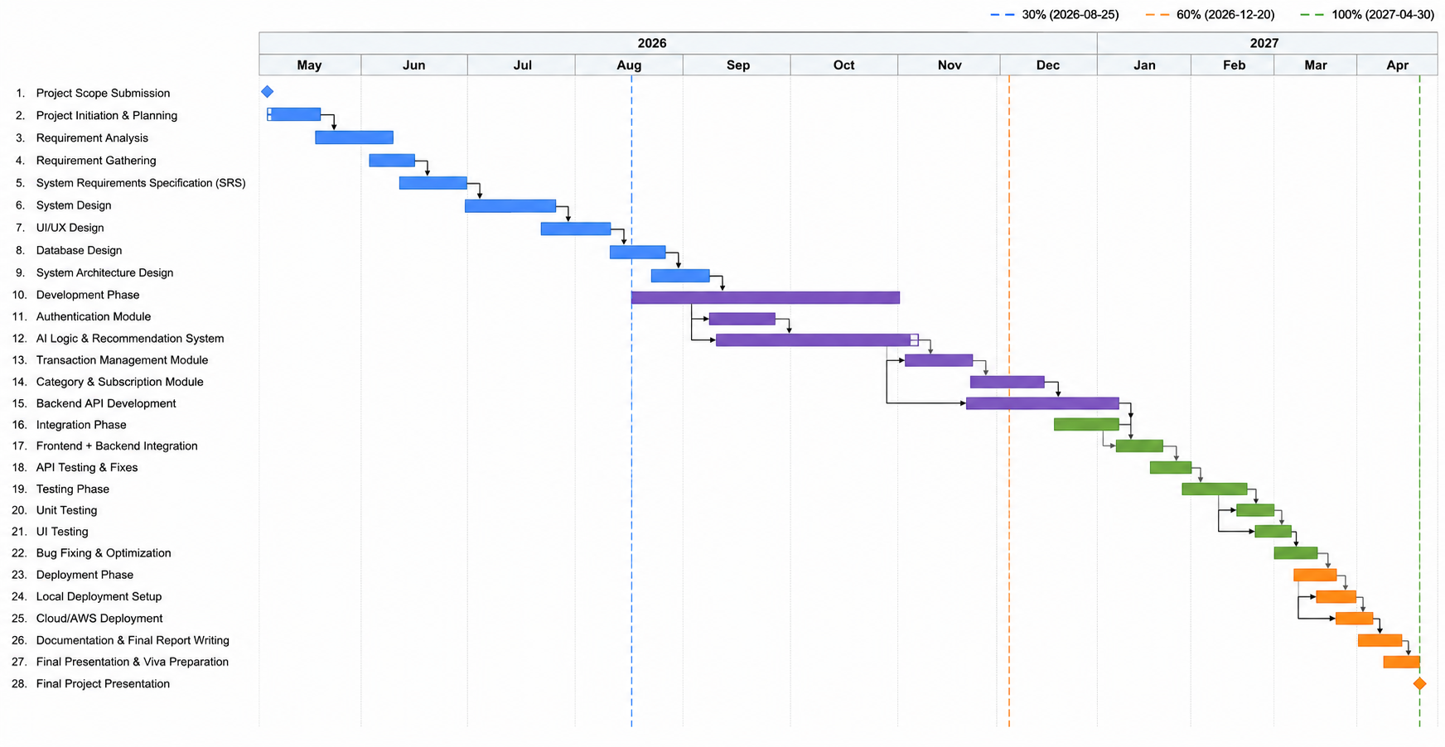
Gantt Chart:

16. Mockups
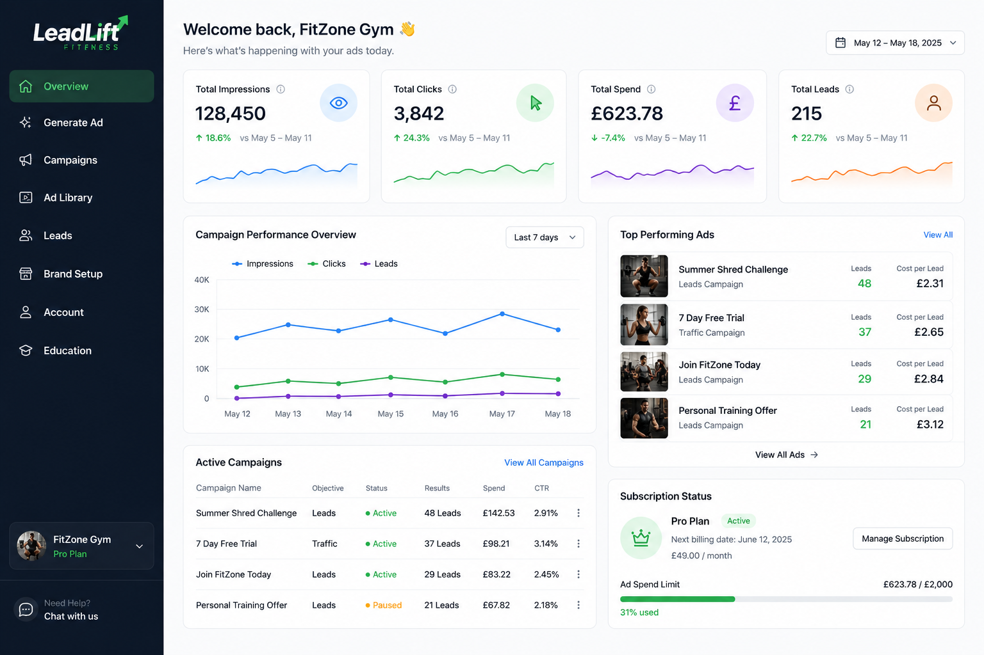
Mockup 1: User Dashboard Home / Overview Screen

Mockup 2: Ad Generator Campaign Configuration Screen
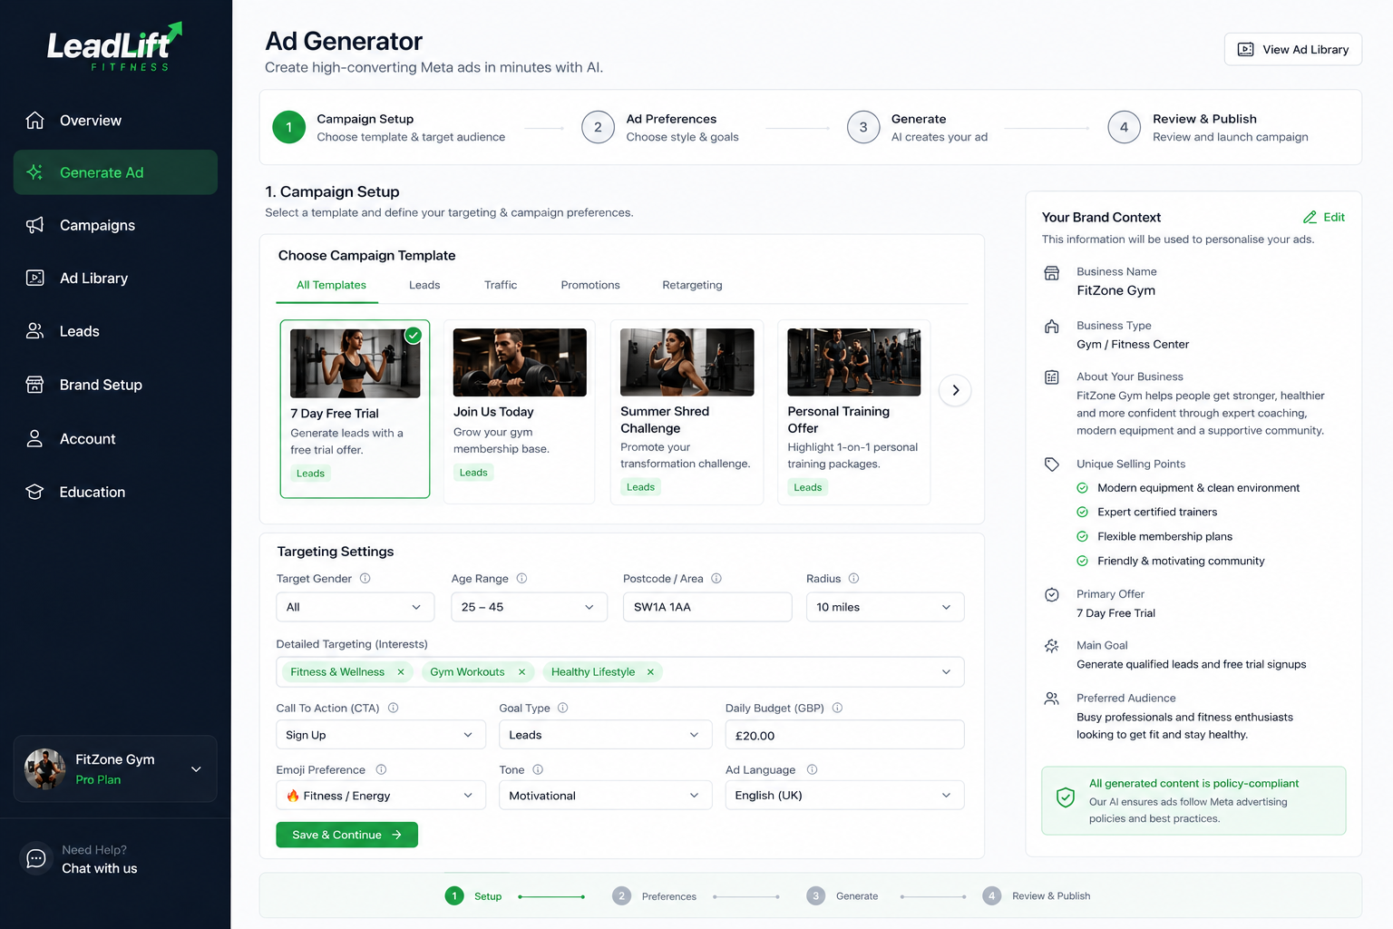
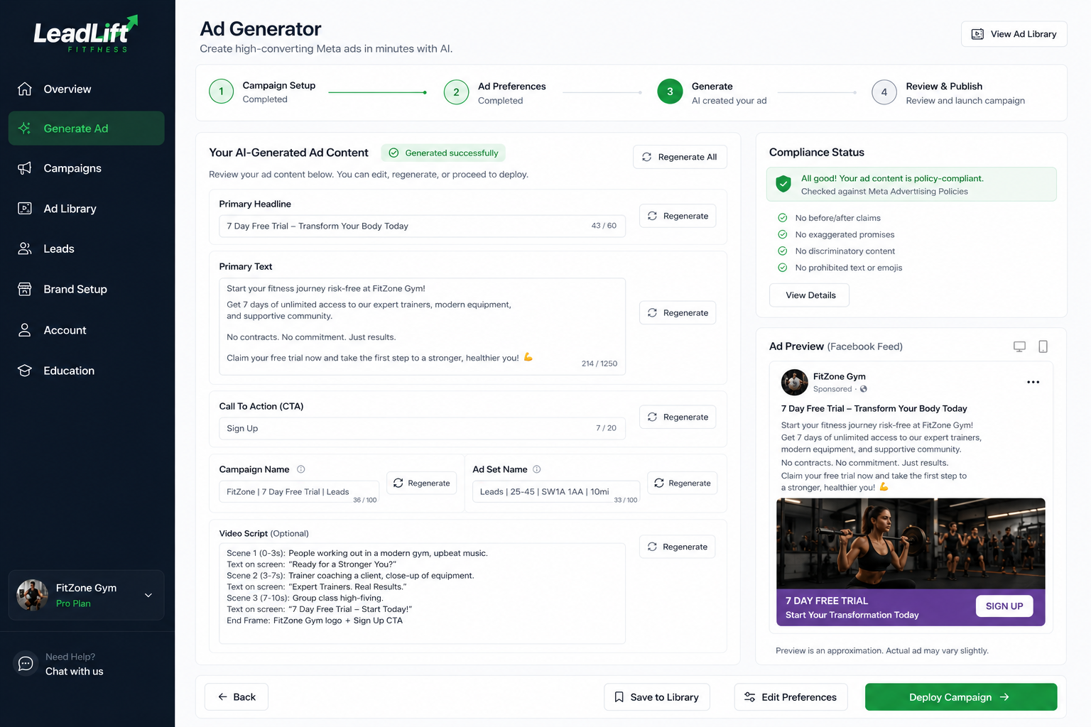
Mockup 3: Ad Generator Generated Ad Content Screen

Mockup 4: Create Ad Modal Meta Campaign Deployment Screen
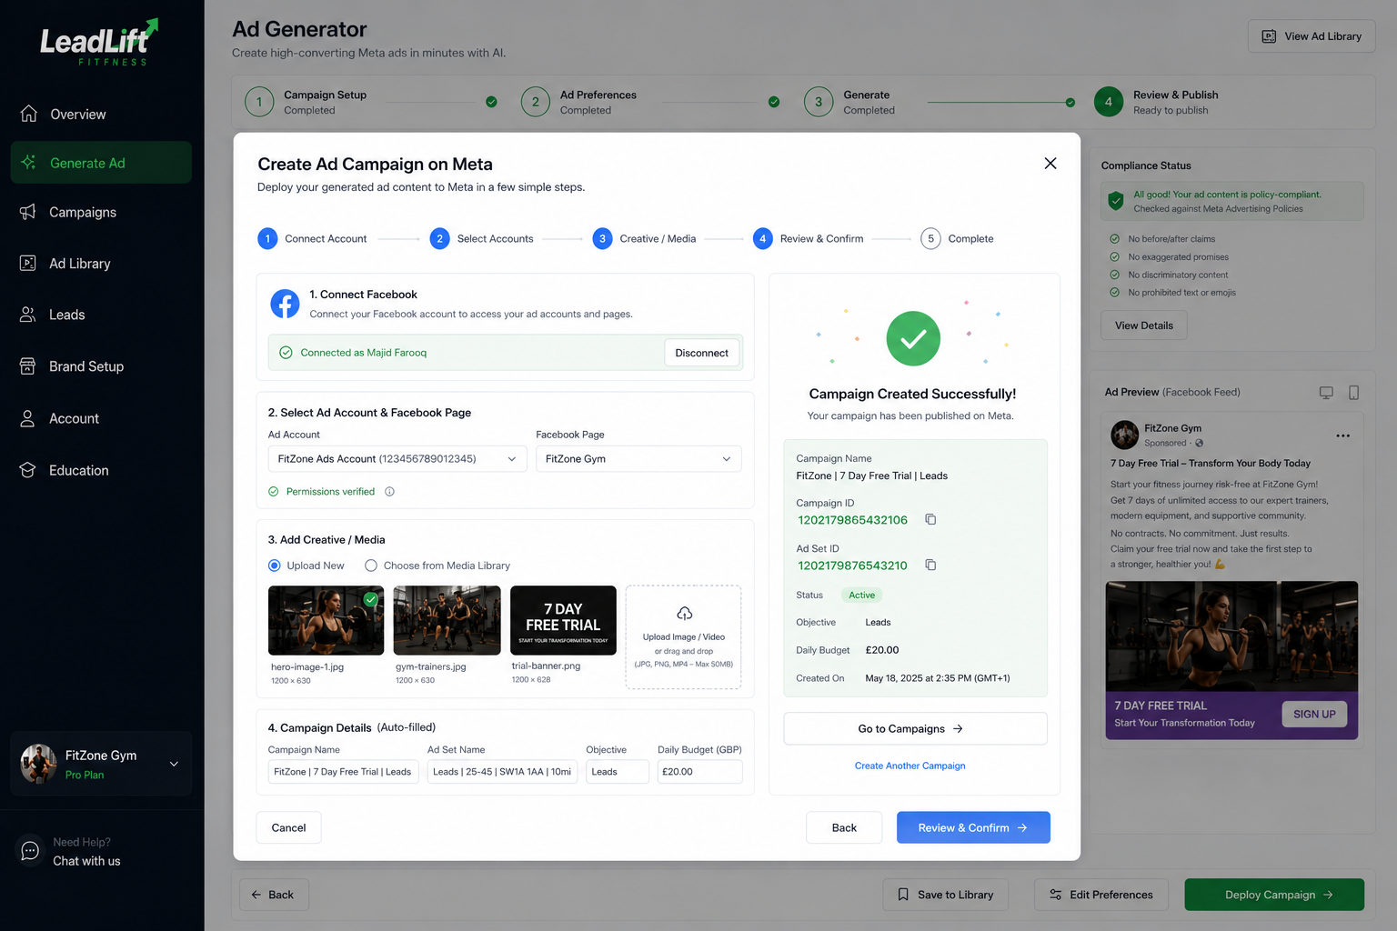
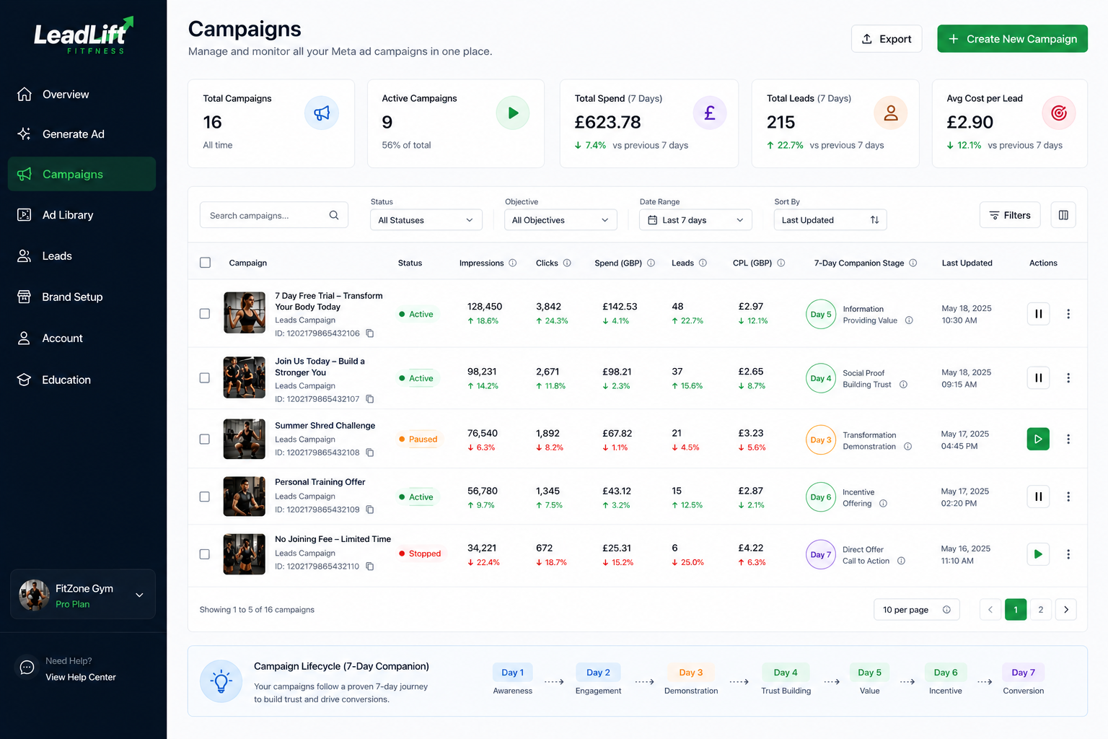
Mockup 5: Campaigns Screen Campaign Management List

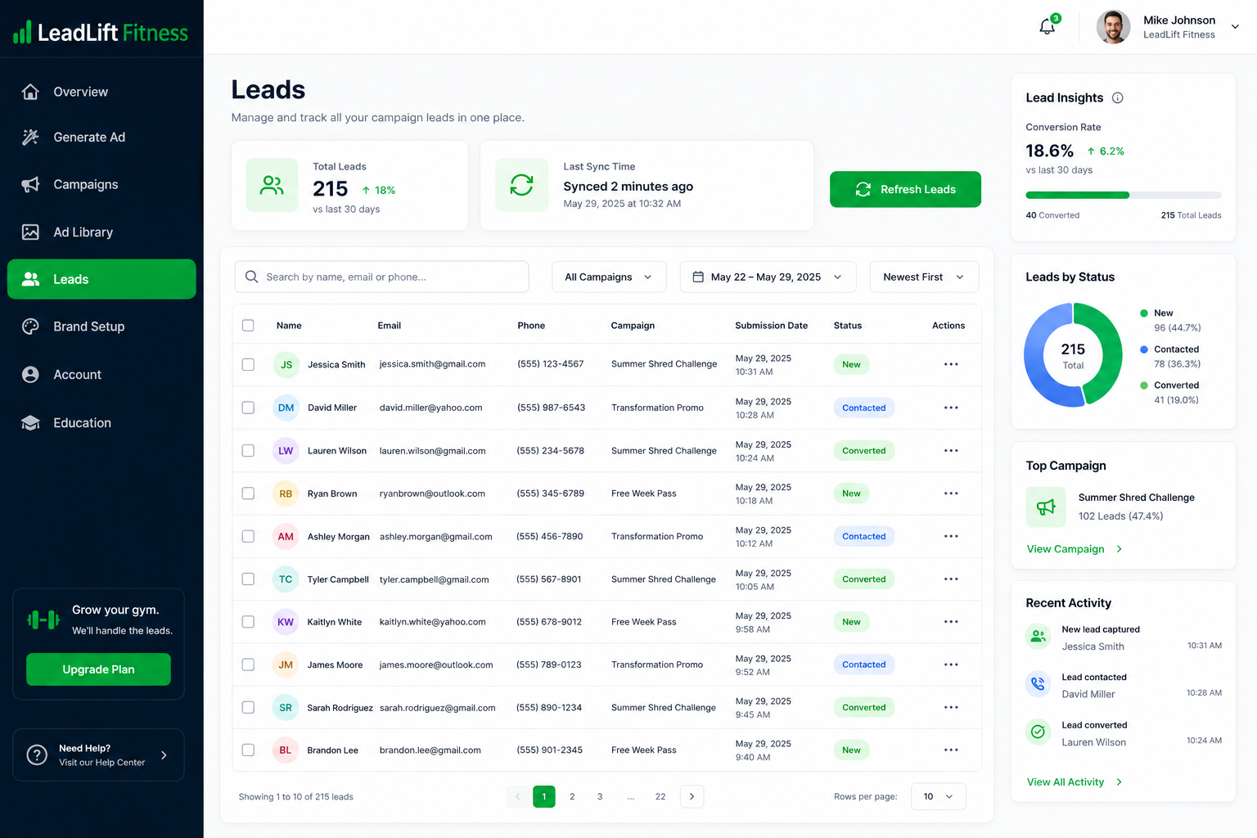
Mockup 6: Leads Screen Lead Management View

17. References
OpenAI, GPT-4 Technical Report. OpenAI, 2023. [Online]. Available: https://openai.com/research/gpt-4.
Meta Platforms, Inc., Meta Graph API Reference Version 18.0. Meta for Developers. [Online]. Available: https://developers.facebook.com/docs/graph-api.
Stripe, Inc., Stripe API Reference. Stripe Documentation. [Online]. Available: https://stripe.com/docs/api.
Amazon Web Services, Amazon S3 Developer Guide. AWS Documentation. [Online]. Available: https://docs.aws.amazon.com/s3/.
MongoDB, Inc., MongoDB Manual Version 6.0. MongoDB Documentation. [Online]. Available: https://www.mongodb.com/docs/manual/.
N. Medvidovic and R. N. Taylor, “A classification and comparison framework for software architecture description languages,” IEEE Transactions on Software Engineering, vol. 26, no. 1, pp. 70–93, Jan. 2000.
R. T. Fielding, Architectural Styles and the Design of Network-based Software Architectures, Ph.D. dissertation, University of California, Irvine, 2000.
BullMQ Contributors, BullMQ Documentation. [Online]. Available: https://docs.bullmq.io
Vercel, Inc., Next.js Documentation App Router. [Online]. Available: https://nextjs.org/docs.
Google, Using OAuth 2.0 for Web Server Applications. Google Developers. [Online]. Available: https://developers.google.com/identity/protocols/oauth2/web-server.
A. Narayanan et al., Bitcoin and Cryptocurrency Technologies. Princeton University Press, 2016.
OWASP Foundation, OWASP Top Ten. 2021. [Online]. Available: https://owasp.org/www-project-top-ten/

18. Plagiarism Report

